Department of Computer Science and Engineering (Data Science)
CSDS-A | Batch A7 (CSE - Data Science, Section A)
SHEGUARD: AI Powered Women's Safety Platform
S.No. | Student name | Roll / hall ticket no.
1 | CH.AARTHI | 23K91A6741
2 | D.PRANATHI | 23K91A6748
3 | BALA VIGNESH | 23K91A6717
4 | A.VISHAL | 23K91A6704
Under the guidance of: [GUIDE NAME], [DESIGNATION]
METHODOLOGY, NOVELTY AND KEY CONTRIBUTIONS
This document describes how SHEGUARD works from end to end, why its methods were chosen, what is different from the base paper, and the contributions of the project. All figures are measured values from the project's own artefacts (docs/REPORT_FACTS.md).

1 Overall Methodology
SHEGUARD follows the lifecycle of an unsafe journey: before it, while it happens and after it. Before the journey the user plans a route; OpenStreetMap-based routing (OSRM) returns driving alternatives and each is scored against a table of district-level risk tiers that was built from public crime statistics with K-Means clustering. During an emergency a single tap, or a spoken cover phrase recognised in the browser, starts a session: the position is streamed to guardians over a WebSocket on a link that needs no login, alerts are attempted by Telegram and e-mail, and the user can add photo or audio evidence. After the emergency the evidence is already stored with a timestamp, a location and a SHA-256 hash, and an AI assistant (Gemini) is available for advice.
The base paper [1] builds the first stage only: it clusters regions with K-Means and Gaussian mixtures on crime, population, literacy, expenditure, police and forest data, and proposes a cab-service integration that raises alerts when a ride deviates into an unsafe cluster. SHEGUARD keeps the idea of a clustering-based risk map feeding route guidance, simplifies it (one feature, one algorithm, three tiers) and adds the hands-free activation, live guardian tracking, evidence preservation and assistant stages around it.
One difference from the batch abstract must be stated at the outset. The abstract names Flutter, Supabase and Postgres Row Level Security. The implementation is a React 19 and TypeScript web application, installable as a progressive web app, on a FastAPI and SQLite back end. Access control is enforced in code: every query filters on the user id carried in the JWT, and guardians have no account at all, they hold only an unguessable per-session link. "Smart SOS" is a one-tap button with a three-second hold to cancel; there is no shake, power-button or fall-detection trigger.
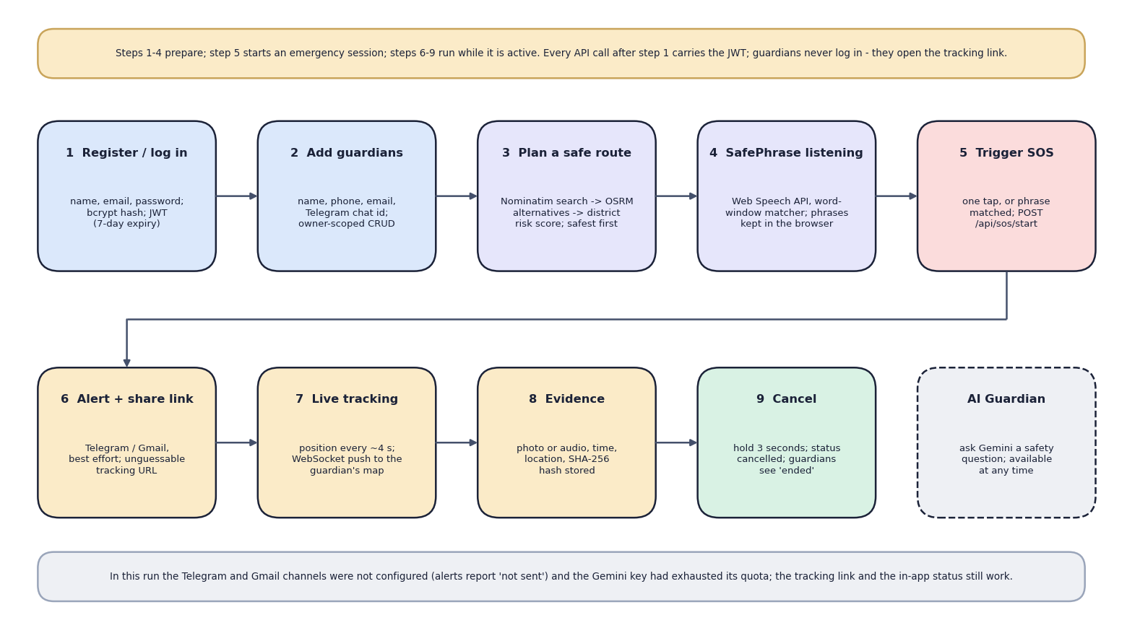
Fig. 1: High-level workflow of SHEGUARD
Table 1: Pipeline of SHEGUARD
Stage | Method | Output
1 Collect | Public district-wise crimes-against-women table 2001-2012 (Kaggle, CC0); districts geocoded once with Nominatim | 9,017 rows, 827 districts, 467 with coordinates
2 Prepare | Drop TOTAL rows; sum seven crime columns; average per reporting year; join with coordinates | One crime_rate per district
3 Cluster | StandardScaler and K-Means with k = 3; tiers named by mean crime rate; 0-100 risk_score by min-max | 467 district rows (low 278, medium 148, high 41)
4 Plan route | OSRM alternatives; every 8th point mapped to the nearest district (haversine); tier weights 1 / 2.5 / 5, night factor 1.6 | Routes sorted by risk score; first is recommended
5 Trigger | One-tap button, or the Web Speech API plus a word-window matcher against stored phrases | POST /api/sos/start with the trigger name
6 Share | Session row with a 32-hex share_token; position pings every 4 s; WebSocket broadcast; Telegram and Gmail attempts | Public read-only tracking page; delivery report
7 Preserve | Multipart upload, SHA-256 of the bytes, stored file, row with kind, time and position | Evidence list with 64-hex hashes
8 Assist | Gemini generateContent with a safety system prompt and the approximate location | Short answer (not demonstrated in this run: quota error)

2 Dataset
The only learned component of the product, the area-risk model, is trained on public statistics; there is no synthetic data and no labelled ground truth. Two Kaggle datasets were committed to the repository and the district coordinates were produced once from OpenStreetMap.
Table 2: Data used by SHEGUARD
Item | Source and licence | Size and use
District crimes file | Kaggle "Crime in India" (rajanand) [23]; CC0 public domain | district_wise_crimes_against_women_2001_2012.csv: 9,017 rows, 8,597 after dropping TOTAL roll-ups; 35 states and union territories; years 2001-2012; 827 (state, district) pairs; seven crime columns. Trains the model
State-year file | Kaggle "Crimes against women in India 2001-2021" (balajivaraprasad) [24]; CC0 | crimes_against_women_2001_2021.csv: 736 rows, 70 state labels, 2001-2021. Committed, not used by any feature
District coordinates | Nominatim over OpenStreetMap (ODbL) [29]; one request per second | districts_geocoded.csv: 467 of 827 pairs (56.5 %); the rest (railway divisions, sub-district entries) were dropped, not guessed
Routes | OSRM public demo server [17]; place search by Nominatim | Fetched live per request; nothing stored

The seven counted categories are Rape, Kidnapping and Abduction, Dowry Deaths, Assault on women with intent to outrage her modesty, Insult to modesty of Women, Cruelty by Husband or his Relatives and Importation of Girls. Their combined shares are Cruelty by husband or relatives 40.0 %, assault on modesty 25.8 %, rape 13.0 %, kidnapping 11.7 %, insult to modesty 5.2 % and dowry deaths 4.2 %. The risk score therefore mostly counts domestic-violence reports, which say little about danger on a street at night; this is a property of the data and is repeated among the limitations.
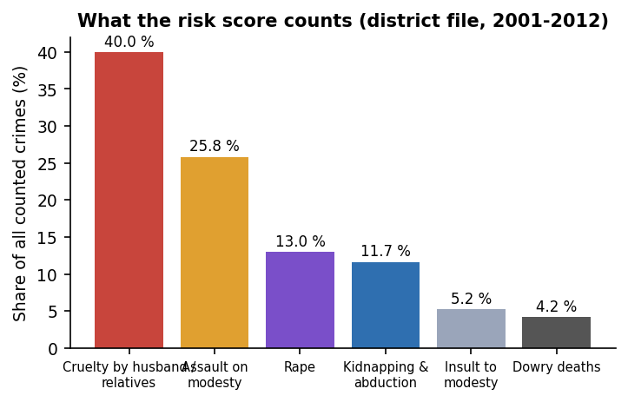
Fig. 2: Share of each counted crime category in the district file
Districts report between one and twelve years: 638 of 827 report all twelve and 34 report a single year; the geocoded districts average 11.71 reporting years. The feature is an average per reporting year, so a district with five years of data is not penalised for its missing years, but the average of a few years is noisier. The counts are raw numbers, not rates per population: the file contains no population, so a large district ranks above a small one with the same per-person risk.
Geocoding left 11 of 35 states and union territories with no district at all (A & N Islands, Chandigarh, D & N Haveli, Daman & Diu, Delhi, Lakshadweep, Puducherry, Tripura, Uttar Pradesh, Uttarakhand, West Bengal), and the geocoded points are otherwise plausible: none lies outside India's bounding box and 2 districts share a coordinate (466 distinct points). There is no train and test split, because the model is unsupervised and there is no ground-truth risk label to hold out.
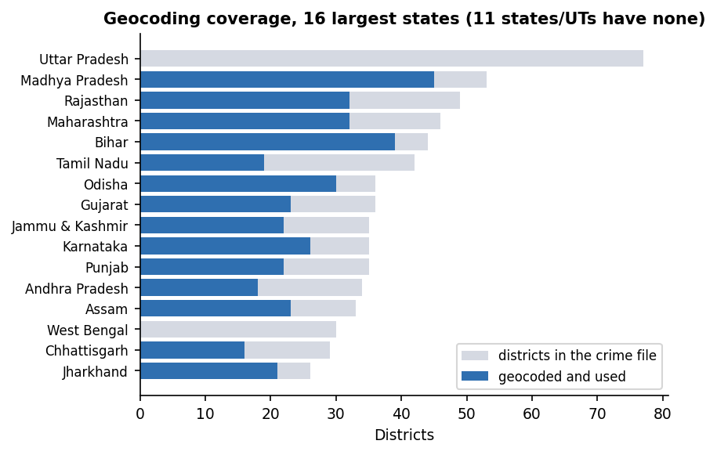
Fig. 3: Districts per state in the crime file and how many were geocoded and used
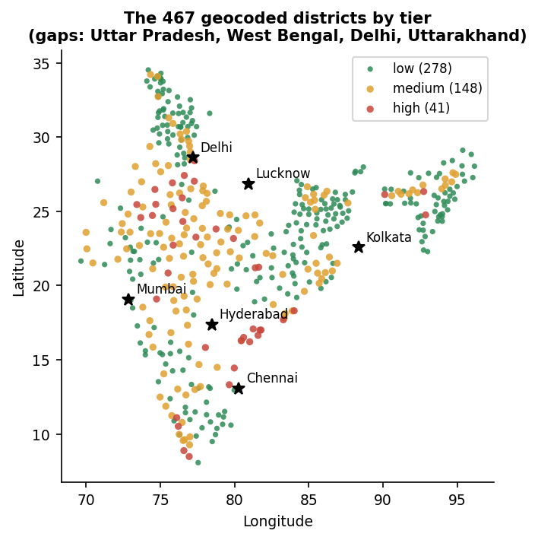
Fig. 4: The 467 geocoded districts coloured by tier

3 Preprocessing

3.1 Building the district feature table
ml/train_risk_model.py prepares the data in five steps:
1. Remove roll-ups. Rows whose district name contains TOTAL (state totals) are dropped, leaving 8,597 of 9,017 rows.
2. Sum the categories. The seven crime columns are added into total_crimes for each row (one district-year).
3. Average per reporting year. Rows are grouped by state and district; crime_rate is the sum of total_crimes divided by the number of distinct years the district reported.
4. Attach coordinates. An inner join with districts_geocoded.csv keeps the 467 districts that have a latitude and longitude.
5. Scale. StandardScaler converts crime_rate to a z-score before clustering; the scaler is saved with the model.
After clustering, the tier names are assigned by sorting the three clusters on their mean crime_rate (lowest is low, highest is high), so the names do not depend on the arbitrary cluster numbers, and risk_score is a min-max rescaling of crime_rate to 0-100 computed within the fitted data. The table is written to data/district_risk.csv and loaded into the district_risk database table when the back end starts.

3.2 Geocoding
scripts/geocode_districts.py asks Nominatim for "District, State, India" once per district, at most one request per 1.1 seconds, and saves its progress after every row so an interrupted run resumes. A district with no result is skipped. The cache is committed, so the step never has to run again.

3.3 Route preprocessing
The OSRM response is requested with alternatives=true, overview=full and GeoJSON geometry; its [longitude, latitude] pairs are swapped to [latitude, longitude]. The scorer takes every eighth point of the polyline (sample_every_n = 8) so that a long route is judged by a few dozen sample points rather than thousands.

3.4 Voice and input preprocessing
SafePhrase text, both the stored phrases and the speech transcript, is normalised by normalizeText: lower-cased, every character outside a-z, 0-9 and space replaced by a space, runs of spaces collapsed and the ends trimmed. The transcript buffer keeps only the last 200 characters so that old speech cannot trigger a new match. A stored phrase is shown to the user only as a SHA-256 fingerprint of its normalised text. Request bodies are validated by Pydantic models (e-mail format, password of at least six characters, required coordinates); the evidence upload checks the kind (photo or audio) and rejects an empty file.

4 Algorithm Choice and Justification
Table 3: Main decisions of the implementation
Decision | Chosen | Alternatives measured or considered | Why
Risk tiers | K-Means, k = 3 on the standardised crime rate [9], [10] | Ward hierarchical [15] (83.3 % agreement), Gaussian mixture [14] (72.6 %), equal-count terciles (49.2 %), fixed 100 / 300 cut-offs (54.6 %) | Simple, deterministic given a seed, fits in milliseconds, matches one of the two algorithms of the base paper; the tier boundaries come from the data instead of being invented
Number of tiers | k = 3 | k = 2 to 8 swept (below) | A UI choice (low, medium, high); not the optimum of the indices
Features | One: average crimes per reporting year | Base paper: crime, population, literacy, expenditure, police, forest | Only the crime counts were available in the committed data; no population to normalise by
Route score | Mean of tier weights over sampled points, times a night factor | Distance-weighted interpolation between districts; learned weights | Transparent: every score can be explained from three weights; no labelled routes exist to learn from
Spatial lookup | Nearest district by haversine distance over all 467 rows | Polygon containment; k-d tree | No district boundaries were available; 467 rows need no index (but there is no distance limit)
Routing | OSRM public server [17] over OpenStreetMap [18] | Commercial map APIs | Free, returns alternatives and full geometry, no key
Voice trigger | Web Speech API [25] plus a word-window matcher | Exact substring only; edit distance; an on-device keyword spotter | Runs in the browser with no extra service; tolerates one missed word at higher sensitivity; no model to train
Live location | WebSocket broadcast keyed by share token [20] | Polling the tracking endpoint | Guardians receive a position 15 ms on average after the update (measured locally, one viewer); no polling load
Evidence integrity | SHA-256 of the uploaded bytes [22] | Digital signatures; blockchain anchoring | Cheap (about 1 ms per MB), standard, detects any change to the file if it is recomputed
Authentication | bcrypt [21] and HS256 JWT [19] | Sessions; OAuth | Stateless, standard, small code

4.1 Why k = 3, and what the indices say
Silhouette [11] and Davies-Bouldin [12] scores were computed for k = 2 to 8 on the 467 standardised values. k = 3 gives silhouette 0.580 and Davies-Bouldin 0.531. k = 2 has the highest silhouette (0.662) and k = 4 beats k = 3 on both indices (silhouette 0.596, Davies-Bouldin 0.493). The choice of three clusters is therefore a presentation decision, three colours on the map and three weights in the scorer, not the metric optimum. The base paper [1] also reports 3-4 clusters; its tables give silhouette 0.416 and Davies-Bouldin 0.970 at k = 3 on its multi-feature data, which are not comparable with a single-feature result.
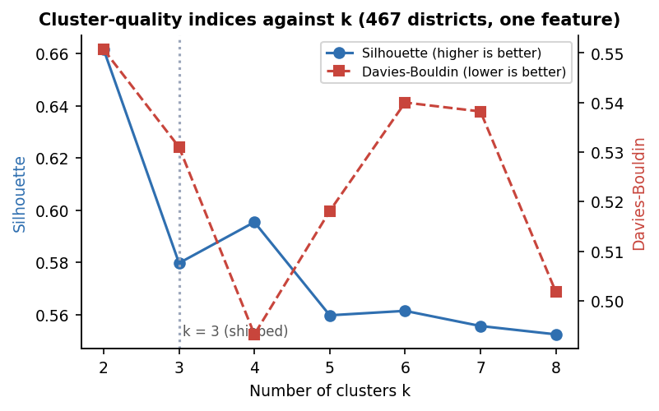
Fig. 5: Silhouette and Davies-Bouldin scores for k = 2 to 8

4.2 What the clustering actually does
Because the data have one dimension, K-Means reduces to two cut-offs on the crime rate: districts below 213.75 crimes per year are low, those from there up to 529.83 are medium and the rest are high. A threshold rule reproduces the K-Means tiers for 100 % of districts. The "model" is therefore a data-driven pair of thresholds, and it is described as such in this report. The consequence for stability is measured in section 6.6.
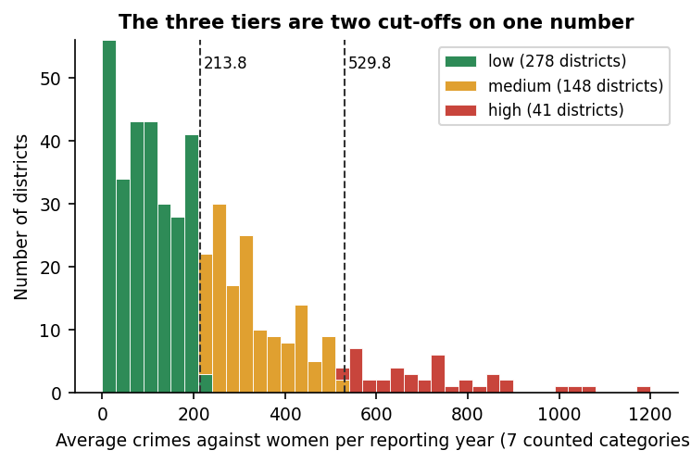
Fig. 6: Distribution of the crime rate with the two cut-offs found by K-Means
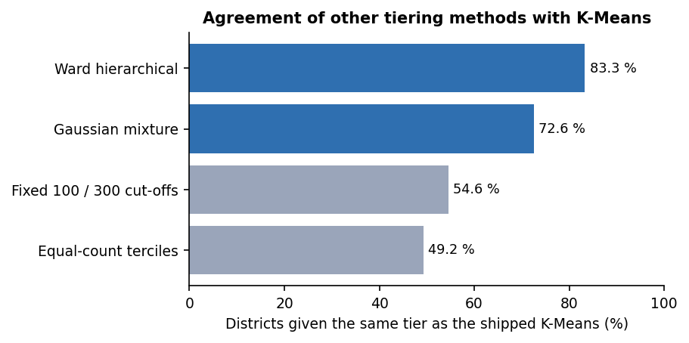
Fig. 7: Agreement of four other tiering methods with the shipped K-Means tiers

5 Mathematical Formulation
The quantities used by the implementation are written below; the symbols are those of the code.

5.1 Crime rate, scaling and risk score
crime_rate(i) = ( sum over years y reported by district i of sum over the 7 categories c of count(i, y, c) ) / n_years(i) (1)
z(i) = ( crime_rate(i) - mu ) / sigma mu, sigma = mean and standard deviation over the 467 districts (2)
risk_score(i) = 100 x ( crime_rate(i) - min ) / ( max - min ) (3)

5.2 K-Means and its quality indices
K-Means [9], [10] chooses cluster centres that minimise the within-cluster sum of squares, with k = 3, random_state 42 and ten initialisations:
WCSS = sum over clusters j = 1..k of sum over districts i in C_j of ( z(i) - c_j )^2 (4)
silhouette s(i) = ( b(i) - a(i) ) / max( a(i), b(i) ), a = mean distance to own cluster, b = mean distance to the nearest other (5)
Davies-Bouldin DB = (1/k) sum over j of max over l != j of ( s_j + s_l ) / d(c_j, c_l) lower is better (6)

The reported values are the mean silhouette 0.5798, DB 0.531 and the Calinski-Harabasz index [13] 1155.4.

5.3 Route risk score
For a route with coordinates p_1 ... p_n, the sample is every eighth point, P = {p_1, p_9, p_17, ...}. Let tier(p) be the risk tier of the district nearest to p, with the great-circle distance
haversine(p, q) = 2 R asin( sqrt( sin^2(dphi / 2) + cos(phi_p) cos(phi_q) sin^2(dlambda / 2) ) ), R = 6371 km (7)
w(low) = 1.0, w(medium) = 2.5, w(high) = 5.0 (8)
night(t) = 1.6 if UTC hour >= 15 (about 20:30-05:30 IST), else 1 (9)
score(route) = night(t) x ( 1 / |P| ) x sum over p in P of w( tier(p) ) (10)

The route with the smallest score is recommended. Because night(t) multiplies every route by the same constant, it changes the size of the score but cannot change which of two routes is smaller; this is proved by the unit test test_night_never_reorders_two_routes and observed on all 16 test pairs (section 6.6 and Chapter 7). The UI also derives a LOW, MODERATE or HIGH label from the tier shares: HIGH when at least 20 % of the sampled points are in high-risk districts, MODERATE when any is or at least half are medium, otherwise LOW.

5.4 SafePhrase matching
Let T be the set of words of a normalised stored phrase (m words) and let the spoken transcript be the word sequence u_1 ... u_L. The matcher returns the best window share
share = max over windows i = 1..max(1, L - m + 1) of | { t in T : t in {u_i ... u_(i+m-1)} } | / m (11)
trigger if the normalised transcript contains the normalised phrase or share >= threshold(sensitivity) (12)
threshold: Low 1.00, Medium 0.85, High 0.75, Ultra 0.60 (13)

Word order inside the window is ignored, and a phrase of three words needs all three at Low and Medium, because two of three is 0.67, below 0.85.

5.5 Evidence integrity, tokens and tracking links
sha256(file bytes) -> 64 hexadecimal characters, stored with the evidence row; the stored file is named by its first 16 characters (14)
JWT claims: sub = user id, exp = issue time + 7 days; signed HS256 with the server secret (15)
share_token = random UUID in 32 hexadecimal characters = 128 random bits, one per emergency session (16)

6 Model Training and Evaluation Procedure
ml/train_risk_model.py loads the two CSV files, builds the feature table of section 6.3, fits StandardScaler and KMeans(n_clusters=3, random_state=42, n_init=10), names the tiers, and writes four artefacts: models/risk_model.joblib (scaler, K-Means model and the cluster-to-tier map; 3,064 bytes), data/district_risk.csv (467 rows), experiments/metrics.json and the console summary. On the development machine (Intel Core i5-12500, 15.7 GB, no GPU used) loading the data takes about 0.05 s and the K-Means fit about 0.12 s, so a retrain is instantaneous. There is no train, validation or test split: the method is unsupervised, there is no label for "how risky a district is", and the same 467 points are clustered and described.
ml/eval.py reloads the table and recomputes the silhouette and Davies-Bouldin scores of the stored tiers, the per-tier statistics and a sanity check that a route made only of high-risk-district points scores 5.0 while one made only of low-risk points scores 1.0. A second script, scripts/run_experiments.py, written for this report, repeats the model on the unmodified data and adds the studies below; it does not overwrite any shipped artefact.
Table 4: Evaluation of the area-risk model
Measure | Value
Districts clustered | 467
Silhouette / Davies-Bouldin / Calinski-Harabasz | 0.5798 / 0.531 / 1155.4
Tier counts (low / medium / high) | 278 / 148 / 41
Mean crimes per year (low / medium / high) | 97.76 / 327.92 / 720.93
Tier ranges, crimes per year | low 0-212.0; medium 215.5-522.0; high 537.67-1191.58
Agreement of a fresh fit with the shipped district_risk.csv | 100 %
Stability over 30 single-initialisation runs (ARI vs shipped) | minimum 0.659, mean 0.790

The shipped result reproduces exactly: a fresh fit gives the same silhouette, the same tier counts and 100 % agreement with the committed table. With a single random initialisation instead of ten, the adjusted Rand index against the shipped tiers falls to 0.66 in the worst of 30 runs (mean 0.79), so districts near the two cut-offs change tier with the initialisation; the shipped model is stable only because it fixes the seed.
Other ways of drawing three tiers disagree substantially: Ward clustering agrees on 83.3 % of districts (231 / 164 / 72 districts), a Gaussian mixture on 72.6 % (181 / 214 / 72), equal-count terciles on 49.2 % and fixed 100 and 300 cut-offs on 54.6 %. The size of the "high" tier (41 districts) is thus a consequence of the method and not a fact about India. The highest crime rates are West Godavari (1,191.6 per year), Vijayawada (1,059.0, five reporting years), Guntur (1,032.5), Jaipur (1,001.4, five years) and Krishna (895.2); 12 of the 41 high-tier districts are in Andhra Pradesh and 11 in Rajasthan.

6.1 Route scoring evaluation
The route scorer has no labelled data either, so it was exercised on 16 real city pairs from the OSRM server (responses cached in experiments/study/osrm_cache.json). 10 pairs returned two alternatives and 6 returned only one, so for those trips there is nothing to choose between. The recommended route was also the OSRM fastest in 11 of 16 pairs, and where alternatives existed the safest pick cost on average 3.7 extra minutes. The day and night orderings were identical in 16 of 16 pairs; tier weights of 1 / 2 / 3 or 1 / 3 / 9 changed the recommendation in 0 of 10 pairs and sampling every 1, 4, 16 or 32 points instead of 8 changed it in 1. Scoring one route takes about 304 ms of pure-Python distance computation.
The weakness is coverage. nearest_district has no distance limit, and for 40 Indian city centres the nearest geocoded district is a median 8.1 km away but up to 231.3 km: Hyderabad is 149.0 km from its nearest district, Lucknow 231.3 km, Kolkata 190.7 km and Kanpur 164.3 km; 7 of the 40 are more than 100 km away. Along the 16 test routes the mean distance from a sample point to the district that scored it was 61.9 km (maximum 231.3 km). A route through such a city is scored with the tier of a district hundreds of kilometres away.
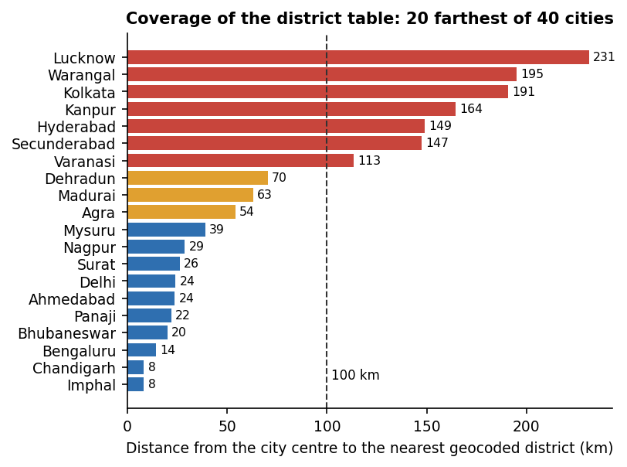
Fig. 8: Distance from city centres to the nearest district in the risk table
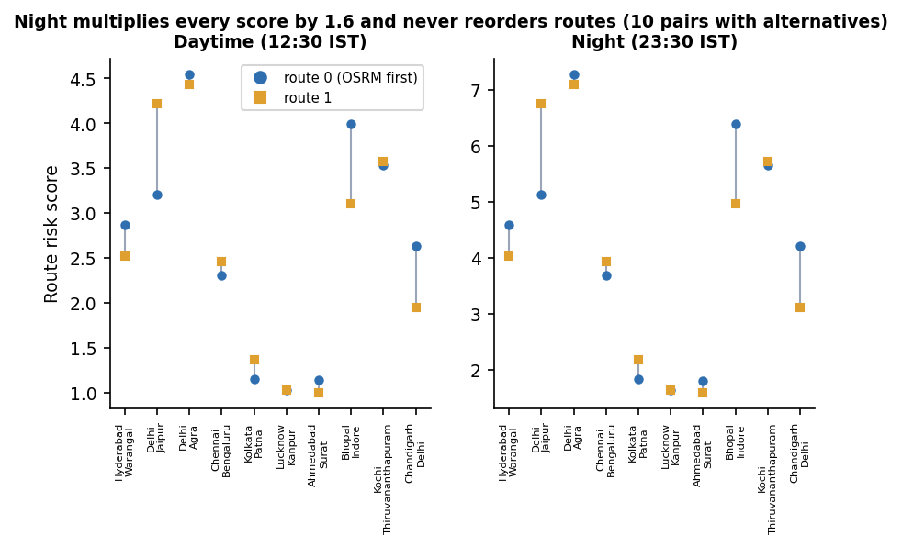
Fig. 9: Route scores by day and by night for the ten city pairs that returned two routes
How the figures were produced. scripts/run_experiments.py imports the product's own backend/app/services/risk.py; scripts/measure_api.py, scripts/safephrase_eval.mjs and scripts/assistant_eval.py measure the running API, the SafePhrase matcher and the assistant, and tests/ holds the automated tests. Results are written to experiments/study/.

7 Base Paper Analysis
Base paper. K. Agrawal, A. Srivastava, K. Sharma, S. K. Satapathy, S.-B. Cho, S. Mishra, A. Chowdhury, and A. Pal, "SafeRoutes: Charting a secure path - A holistic approach to women's safety through advanced clustering and GPS integration," IEEE Access, vol. 12, pp. 166368-166378, 2024, doi: 10.1109/ACCESS.2024.3488784.
Problem and scope. Agrawal et al. address the safety of women in urban environments, and argue that traditional safety initiatives anchored in law enforcement and infrastructure need to be complemented by data analytics, because conventional methods suffer from subjective labelling and from too little labelled data about women's safety. They propose SafeRoutes, a framework with three parts: a data-ingestion pipeline connected to public and government sources, unsupervised machine-learning models that cluster regions by safety, and an integration with map services and cab vendors that visualises rides, draws a safety radius around a recommended path and alerts a driver who drifts into an unsafe area.
Data and preprocessing. All data are taken from the Open Government Data Platform India (data.gov.in): district-wise population for 2001 and 2011, crimes reported under the Indian Penal Code in 2013 with a focus on women, literacy, per-capita total expenditure, police-inspector strength for 2013, an additional district population table with demographic and social indicators, and forest cover. Preprocessing consists of missing-value imputation by mean, median or k-nearest-neighbour imputation, feature engineering such as population growth rate, scaling with a standard or min-max scaler, and feature selection through a correlation matrix and principal component analysis or model-based importance. The paper does not state how many districts the final table holds.
Method. Parameters judged relevant to women's safety, such as rape and kidnapping cases, police presence and infrastructure, are chosen from domain knowledge and ranked with the Pearson and Spearman correlation indices. K-Means and Gaussian mixture models are then compared [9], [14], and three to four clusters are reported to fit the data. Because no cluster can be called safe without a label, the authors add dummy data for cities described as the safest in the world and give a score of 100 to the cluster that contains the most of them. For travel, the paper describes a flow chart in which a cab service requests a safe path, a 1.96 times safety buffer (a confidence interval) tolerates construction diversions, a deviation into a red zone raises alerts and rerouting, and persistent deviation escalates to authorities.
Reported results. The results section is a description of the study. It offers correlation matrices (Pearson and Spearman), a label-encoded table, and an ablation of clustering choices: explained variance against the number of clusters, Gaussian-mixture Bayesian information criterion scores, a Ward dendrogram [15], and three validity indices. As printed in its tables, the silhouette values are 0.440 for two clusters and 0.416 for three, the Calinski-Harabasz index [13] is 264.7 for two clusters, 221.0 for three and 222.7 for four, and the Davies-Bouldin index [12] is 1.021, 0.970 and 1.011 for two, three and four clusters; three clusters give the lowest Davies-Bouldin value of the three. The abstract and conclusion describe the outcomes as anticipated: heatmaps, classified regions and a benchmark for future research. The paper gives no accuracy, precision or latency figure, and the cab integration is described but neither implemented nor evaluated. (The paper's silhouette plot shows values near 0.25 to 0.31, which differ from its Table 3; the tables are quoted here as printed.)
Strengths. The paper uses several public sources, justifies its feature selection statistically, compares clustering algorithms with several validity indices, discusses bias in crime data and under-reporting, and links area risk to the act of travelling, which most clustering studies do not.
Limitations, as we read them. The results are anticipated outcomes rather than measured system performance; the number of districts and the final feature set are not stated; the 'safest city' reference data are dummy values; the 2013 crime year is a single snapshot; and the cab integration, which is the part that touches the traveller, has no implementation or user evidence.
What SHEGUARD adopts. The central idea: group districts by recorded crime into a small number of risk tiers without labels using K-Means, and use the tiers to guide travellers on a map. SHEGUARD also uses the Davies-Bouldin and silhouette indices [11], [12] to check the clustering.
What differs. SHEGUARD uses one feature (average counted crimes per reporting year, 2001-2012) rather than a multi-source table; it fixes three tiers rather than choosing the number from the data; it has no population, literacy, expenditure or police data and no Gaussian mixture analysis in the product; and instead of a cab-vendor alert it implements a route scorer on routing alternatives, plus SafePhrase and one-tap activation, a live guardian link, hashed evidence, an assistant and an installable web app. Because data, features and tasks differ, the validity indices of the two works are not comparable and no claim of superiority is made.
Table 5: Base paper and SHEGUARD compared
Aspect | Base paper [1] | SHEGUARD
Data | data.gov.in: population 2001 and 2011, IPC 2013, literacy, expenditure, police strength, forest cover | Kaggle district-wise crimes against women, 2001-2012, one derived feature; coordinates from Nominatim
Clustering | K-Means and Gaussian mixture, 3-4 clusters chosen with indices | K-Means, k = 3 fixed, on one feature; tiers are two cut-offs
Cluster indices reported | Silhouette, Calinski-Harabasz, Davies-Bouldin, BIC (tables) | Silhouette 0.580, Davies-Bouldin 0.531, Calinski-Harabasz 1155.4 on 467 points
Travel integration | Cab-vendor safe path, 1.96 times buffer, deviation alerts (designed, not evaluated) | OSRM alternatives scored by district tier and time of day (implemented, measured)
Emergency functions | None in the paper | One-tap SOS, SafePhrase, live guardian link, hashed evidence
Assistant, user interface | None in the paper | Gemini-backed assistant; installable React web application
Reported evidence | Anticipated outcomes; cluster-selection tables; no accuracy | Measured clustering quality, route-scoring study, 57 tests, API latencies; assistant and alert delivery not demonstrated

8 Novelty Compared with the Base Paper
The base paper [1] (Agrawal et al., IEEE Access, 2024) is a clustering-and-GPS framework for women's safety on urban journeys: it ingests public data, clusters regions with K-Means and Gaussian mixture models, and designs a cab-service integration with deviation alerts. SHEGUARD keeps the first idea, grouping districts into risk tiers without labels, and uses it to guide routes on a map. The rest is different: SHEGUARD adds the functions that the base paper does not have, and it leaves out data and analysis that the base paper has. The table lists the differences. None of the additions is claimed as new to the field, and the two works are not compared numerically because their data, features and tasks differ.
Table 6: What differs from the base paper
Element | Base paper [1] | SHEGUARD (this project)
Stage of the incident | Before and during a journey: area risk, safe path, deviation alert | Before (route scoring), during (SOS, live link) and after (hashed evidence)
Input data | Population 2001 and 2011, IPC 2013, literacy, expenditure, police strength, forest cover | District crimes against women 2001-2012 reduced to one count per year; 467 geocoded districts
Learning | K-Means and Gaussian mixture, 3-4 clusters chosen with silhouette, Calinski-Harabasz, Davies-Bouldin and BIC | K-Means with k = 3 fixed; indices reported; Ward and Gaussian mixture tiers compared in the study
Reference scoring | Dummy data of globally safest cities, score 100 for the best cluster | Tier weights 1.0, 2.5 and 5.0; night factor 1.6
Travel integration | Maps APIs and cab vendors; 1.96 times buffer; alerts and rerouting (not implemented or evaluated) | OSRM alternatives scored and sorted; recommended route highlighted on a Leaflet map
Activation | None | One-tap SOS; spoken SafePhrase with four sensitivity levels; three-second hold to cancel
Guardians | Cab drivers are alerted | Telegram and email to each guardian; private tracking link; live position over a WebSocket with no guardian login
Evidence | None | Photograph and audio with time, location and SHA-256 hash
Assistant and platform | None | Gemini-backed assistant; installable React web application; FastAPI and SQLite
Access control | Not discussed | Per-user filtering of every query, bcrypt and signed tokens; no Row Level Security, no administrator role
Evidence of performance | Anticipated outcomes; cluster-selection tables | Measured clustering quality, route-scoring study, SafePhrase matcher test, API latencies, 57 automated tests and live access-control probes

The abstract of the batch names a Flutter application, a Supabase back end and Postgres Row Level Security. These were not used: the delivered system is a React and TypeScript progressive web app with a FastAPI and SQLite back end, and the isolation of users' data is done in the application code. The batch abstract also names a Smart SOS; the delivered activation is a one-tap button and a spoken phrase, with no shake, power-button or automatic trigger. What the base paper has and SHEGUARD lacks is also stated plainly: population-normalised and multi-feature data, police-presence and socio-economic features, an analysis that selects the number of clusters, and the cab-service integration with deviation alerts.

9 Key Contributions
1. An integrated platform for the whole emergency lifecycle. One application that links route guidance, one-tap and spoken activation, live guardian tracking, hashed evidence and an assistant, with 19 REST endpoints, one WebSocket route and six database tables, extending the safe-route idea of the base paper [1] into a working system.
2. An area-risk table with its limits measured. K-Means (k = 3) on one feature, the average number of counted crimes per reporting year, groups 467 geocoded districts into 278 low, 148 medium and 41 high tiers (silhouette 0.580, Davies-Bouldin 0.531). The study shows that this amounts to two cut-offs (213.75 and 529.83 crimes a year), compares other tiering methods (agreement 49% to 83%), and shows that 56.5% of districts were geocoded and that none exist for Uttar Pradesh, West Bengal or Delhi.
3. A route scorer evaluated on real routes. Alternatives from OSRM are scored by sampling the polyline and weighting the nearest district's tier 1.0, 2.5 or 5.0. On 16 real city pairs, 10 had two alternatives; the night multiplier of 1.6 never changed the recommended route, and the safest alternative cost 3.7 minutes more on average.
4. A SafePhrase matcher with a measured trade-off. A word-window matcher over the browser transcript, with four sensitivity levels, triggered on 54.2% of 24 written phrase variants at the default level with no false trigger in 80 checks, and on 100% at the most sensitive level with 10% false triggers.
5. Live guardian tracking and tamper-evident evidence. Position pushes reach a viewer in about 16 to 20 ms on the local machine; each photograph or audio file is stored with a SHA-256 hash that changes if a single bit is flipped.
6. A tested and honestly documented code base. A suite of 57 automated tests (51 pass, 6 expected failures that document real defects), live access-control probes, measured latencies and the defects found by testing are reported instead of hidden.
Contributions 1, 5 and 6 are engineering contributions; contributions 2, 3 and 4 are those whose quality was measured. Compared with the base paper [1], which clusters multi-source district data (population, literacy, expenditure, police strength, forest cover) with K-Means and Gaussian mixtures and designs a cab-service deviation alert, this project uses one feature and a simpler tiering, and adds the in-the-moment functions the base paper does not have. The data, features and tasks differ, so no numeric head-to-head is claimed.

